Viewing Allocations on National Offer Day

Log into SAM Portal, select ‘Secondary 2023’ round and ‘Round Summary’.
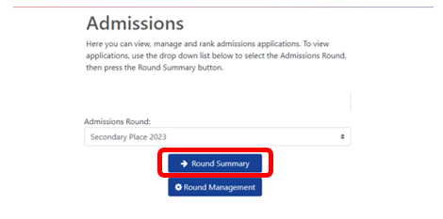

Navigate to ‘View Final Offers’ from the ‘Reports’ section on the bottom right of the page.
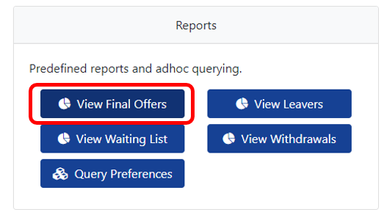

This will present you with a list of all pupils who have been offered a space at your setting for Secondary 2023. Each pupil will be listed individually here

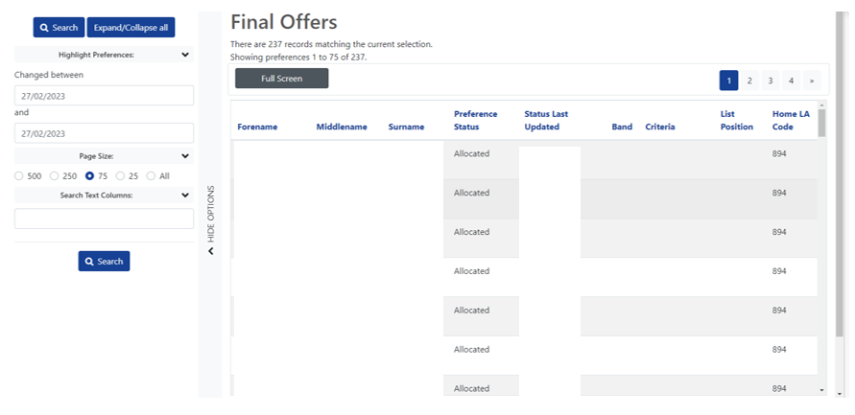

To view further information about each pupil, click on their name and you will be able to see the application details showing date of birth, address, current school etc.
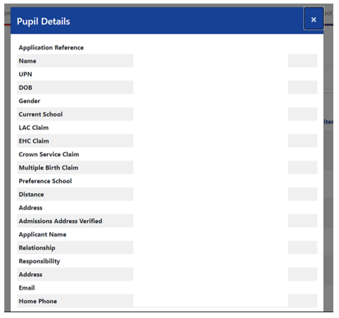
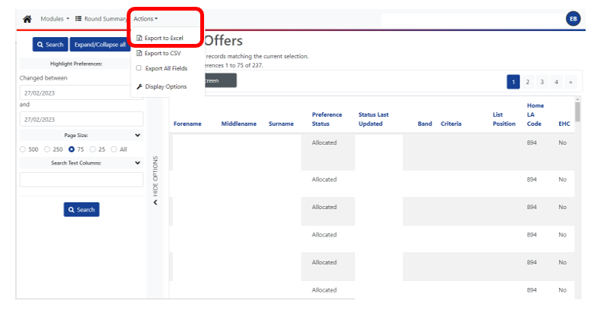
The offer list can then be exported to an Excel by selecting ‘Actions’ and ‘Export to excel’. Your list will then download as an Excel document

